Model risk assessment for practical session 04 | DNA extraction

Teachers and Technicians are reminded their employer is responsible for health and safety within their institution. Risk assessments must be carried out for all practical activities included in this programme at the school and college, to include considerations for their particular laboratory, situation and group of students involved. Individual risk assessments should be carried out for each practical activity with each different group (a model risk assessment provides considerable guidance but will not suffice). If the risk assessment indicates that the practical activities are too risky to carry out in that situation, the employer is responsible for ensuring that it is not undertaken.
Schools should be aware of guidance from CLEAPSS (Consortium of Local Education Authorities for the Provision of Science Services) and, where applicable, a school or college should refer to local authority guidelines with regards to specific local rules and guidelines about health and safety.
This model activity risk assessment relates to Practical session 4: DNA extraction.
The first table outlines potential hazards grouped into chemical substances, biological material, ergonomics, physical hazards and vulnerable groups.
The second table provides information on risks, safety precautions, emergency procedures, safe disposal and an assessment of overall risk, based on likelihood of a risk occurring and the severity should it do so.
Hazard | Name | Description | Links
Chemical substances | 10% Chelex | Chelex crystals are made up into a 10% (w/v) suspension in nuclease-free water. When alkaline Chelex suspensions are heated with biological samples, cell membranes are disrupted. Chelex then binds the magnesium ions that are cofactors for nucleases to prevent catalysis of DNA degradation.  Not a classified as a hazardous substance or mixture according to the Globally Harmonized System (GHS). | Chelex 100 Resin SDS  For info on how Chelex works see reference
Biological material | Invertebrate for DNA barcoding | Working with biological material from a native invertebrate in a laboratory environment.
Hazard | Name | Description | Links
Ergonomics | Micropipetting posture | Using a micropipette involves using shoulder, wrist and hand movements that could cause muscular injury if used repeatedly over at least 2 consecutive hours per working day.
 | Environmental factors | Environmental factors, including insufficient space, low lighting levels and strong air movements or drafts could be a hazard.
Physical hazards | Equipment | Scalpels used to remove a small piece of invertebrate tissue will be sharp.
 | Equipment | Hot water from kettles, or in water baths, can scald.
 | Equipment | The microcentrifuge and heating equipment are powered by 240V.
 | Heat | Kettles, water baths and heating blocks will be hot and can burn.
Vulnerable groups | Young people | Inexperience in laboratory procedures means that all hazards can give an increased risk to young people.
 | New or expectant mother | All controls in place protect new or expectant mothers during laboratory procedures.
 | Disabilities and health issues | Laboratory procedures can sometimes be more challenging for those with disabilities or health issues

When judging risks, it is assumed that:
- All students working in a science laboratory follow good laboratory practice, including: not eating or drinking in the lab, tying back long hair, keeping lab benches clear of clutter, clearing up spills immediately, handling materials and equipment with care, and washing hands with soap after completing lab work.
- All users read, understand and follow guidance from eth Health and Safety section in the student guides.
- Disposal occurs following advice in the educator guides.
Overall risk has been judged using the risk matrix below:
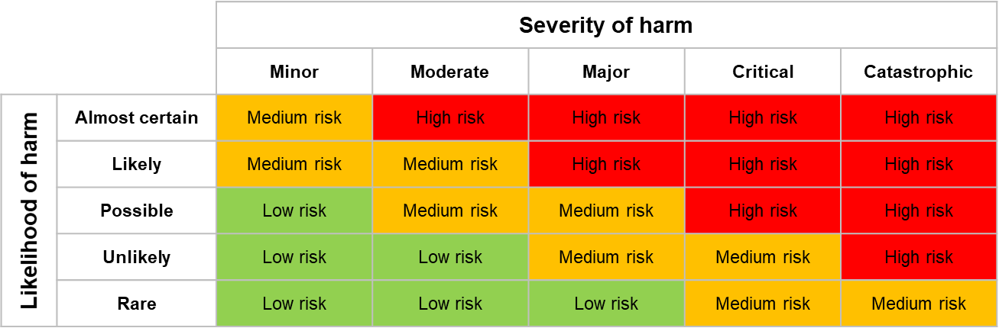

Risk(s) | Safety precautions | Emergency procedures | Likelihood | Severity | Overall risk
Contact with 10% (w/v) Chelex solution | Use good laboratory practice to avoid contact with skin and eyes.  Use non-powdered, nitrile, CL1 gloves as a barrier to contact (eg; Kimtech nitrile gloves 99211) to prevent contamination of the sample. | In case of contact with skin wash off with plenty of soap and water.  If it comes into contact with eyes, rinse thoroughly with plenty of water for at least 15 minutes, lifting lower and upper eyelids. Consult a physician. | Unlikely | Minor | Low
Contact with invertebrate for DNA barcoding | Use in a controlled way, similar to aseptic techniques. | In case of contact with skin wash off with plenty of soap and water.  If it gets into eyes, rinse with water using an eye bath for several minutes. Remove contact lenses, if present and easy to do. | Unlikely | Minor | Low
Unsafe disposal of chemical / biological substances | Discard single-use disposable items, such as pipette tips, and microfuge tubes, into labelled disposable plastic jars for safe disposal.  All pipette tips, tubes and gels that contain biological materials should be placed into an autoclave bag for autoclaving prior to disposal. | If contact is made with skin during disposal of chemical substances, wash with plenty of soap and water.  If chemical substances go into eyes during disposal, rinse thoroughly with plenty of water using an eye bath for at least 15 minutes, lifting lower and upper eyelids. Consult a physician. | Unlikely | Minor | Low
Risk(s) | Safety precautions | Emergency procedures | Likelihood | Severity | Overall risk
Shoulders / wrists / hands sore from micropipette use | Don’t micropipette for long periods (>2 hours) without a break. Stretching is recommended every 20 minutes to minimise risk. | If shoulders, wrists or hands become sore, stop pipetting and stretch. | Unlikely | Minor | Low
Inappropriate environment | Ensure that laboratory work is carried out with sufficient space, lighting and without strong air movements or drafts. | Stop work immediately if the environment becomes unsuitable (eg; if lights go out). | Unlikely | Minor | Low
Cutting a finger with a sharp scalpel | Cut away from yourself and onto a white tile. | Clean cut thoroughly, stop bleeding by covering and applying gentle pressure, cover the wound and call a First aider if needed. | Possible | Minor | Low
Use of electrical equipment | Check that portable electrical equipment (110V and above) fitted with a plug is within 12 months of use from new or has an ‘in date’ PAT Passed label attached.  Portable electrical equipment which is either untested or where the test is 'out of date' should not be used.  Never use electrical equipment with a damaged cable or cracked plug. | Immediately isolate the power and stop using any electrical equipment which is overheating or if signs of damage become apparent during use. | Unlikely | Moderate | Low
Risk(s) | Safety precautions | Emergency procedures | Likelihood | Severity | Overall risk
Scalding from hot water in kettles or water baths | Stand up whilst preparing the water bath, putting in and removing the microfuge tube.  Avoid contact with scalding water. Use a pair of tweezers if needed to remove the sample from the water bath, rather than fingers. | Remove the heat source and cool the scald with cold running water for at least 20 minutes, whilst keeping the injured person warm.  For more severe scalding summon a First aider and seek medical help if required. | Unlikely | Moderate | Low
Burns from kettles, water baths or heating blocks | Ensure that hot surfaces and equipment is clearly labelled.  Avoid contact with hot surfaces. | Remove the heat source and cool the burn with cold running water for at least 20 minutes, whilst keeping the injured person warm.  For more severe burns summon a First aider and seek medical help if required. | Unlikely | Moderate | Low

Risk(s) | Safety precautions | Emergency procedures | Likelihood | Severity | Overall risk
Young people don’t follow laboratory protocols correctly due to inexperience | Clearly explain instructions, answer questions and monitor students as they complete the practical work. | If a student is not following the laboratory procedures or behaving in a way that endangers themselves or others they should be prevented from carrying out the practical work. | Unlikely | Moderate | Low
Impaired health or physical disability makes practical work more risky | Adaptations may be required to facilitate practical work and should be assessed on a case by case basis with advice from support staff, SEN or other appropriate person. | Realistic scenarios can be planned for and assessed on a case by case basis.

